NY GLOBAL ENGINEERING

Company Overview
Safety | Quality | Reliable Service

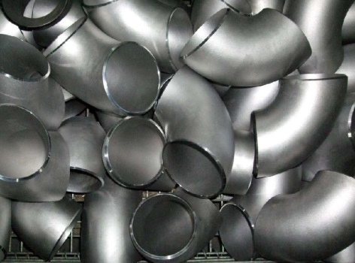
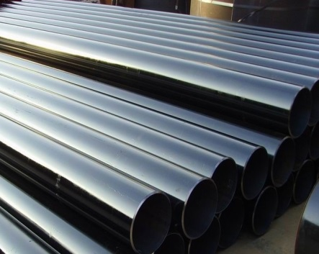
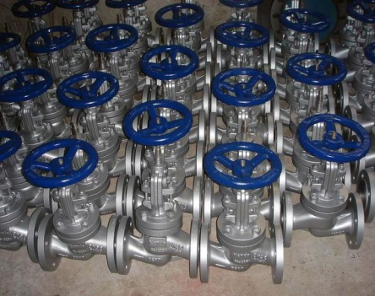
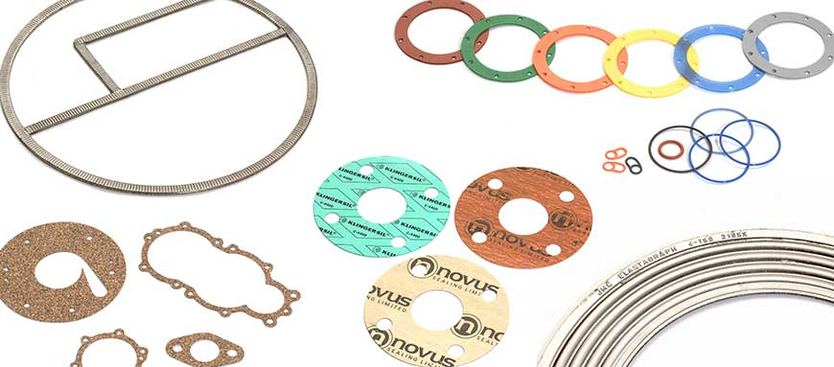





NY GLOBAL ENGINEERING

NY Global Engineering (NYGE) distributes pipes, valves and fittings (PVF) and numerous other products and services to the energy and industrial markets.

Our vast experience in the supply chain of these products will ensure safe, fast, accurate, quality and reliable service to our customer no matter who you are

Our competitive advantages
-In-depth knowledge in upstream and downstream oil and gas industry
-Vast network of worldwide suppliers and fabricators giving you value and quality product and services
- Understanding of International product standards. In other words, we understand your needs
-Our products are from Europe, Asia-pacific, and America Mills that are approved for use by oil and gas majors. Sufficient ex-stock can be turn over with short period to meet tight delivery deadlines
-Ability to handle numerous type of material requisition thus saving your procurement challenges

NY Global has built our business to serve you. Call us today!

Supplier and material
Management
Sourcing
Capabilities
Stable
Suppliers
Competitive
Pricing
One stop
Service
Technical
Product
Support
COMMUNICATIONS
WITH CUSTOMERS
Timely and
Reliable
Delivery Every time
On-Spec
Procurement
Safety and Social
Responsibilities

Quality
Assurance
Performance
Excellence

NY GLOBAL ENGINEERING
PRODUCT RANGE

Pipes
NYGE carries a full range of seamless pipes & welded pipes in compliances to API, BS & JIS standards to serve our customers’ needs. Pipes can be delivered in 6 meters, 12 meters in length or random length/double random length upon request
We offers both standard and line carbon steel pipes in sizes ranging from 1/8” seamless pipe through 54” welded, in various wall thickness, grades and lengths
- Continuous weld (CW)
- Electric Resistance weld (ERW)
- Double submerged Arc Weld (DSAW)
- Seamless
Stainless steel and specialty alloy pipes
Typically used in corrosive, high temperature or high pressure application commonly found in the downstream sector, NYGE can provide the right product for your need. Our stainless steel pipe and specialty alloy pipe is available in seamless or welded in as wide range of sizes from 1/8” diameter through 54” diameter

We work with leading steel producers and manufacturer to secure the highest grade material. No matter what are the specification, material will be arrived on time with proper documentation eliminating delays

Products
Premium
Steel
NY GLOBAL ENGINEERING
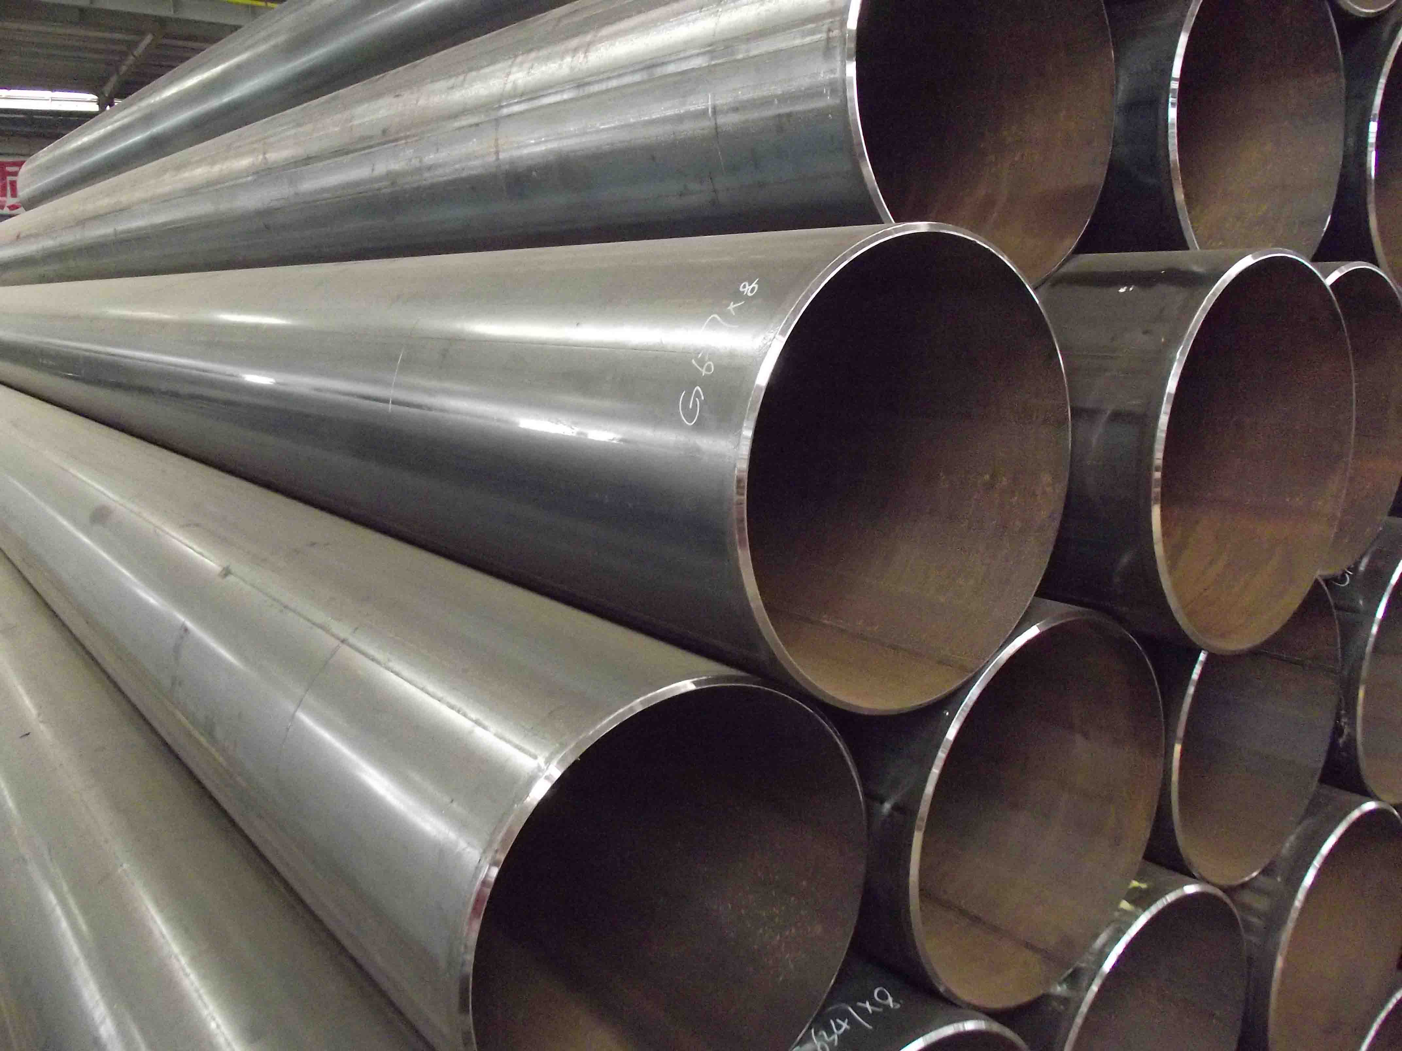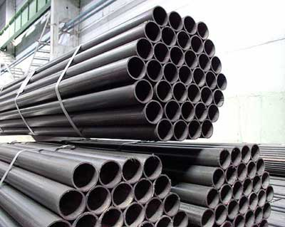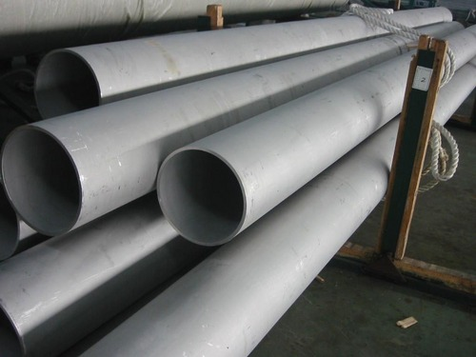

Bolt and nuts
Bolt sizes of ½” to 3½” are readily available for ANSI/ ASME flanges up to 36” in diameter. A193-B&/ A94-2H material are ex-stock ready to supply to our customers for urgent delivery
We also supplies exotic bolts/nuts material including B6, B and big size bolt/nuts suitable for heat exchangers & other pressure vessels equipment upon request.

Our staff includes supply chain specialists who have thorough knowledge of best practise throughout infrastructure industries

& Quality
Value
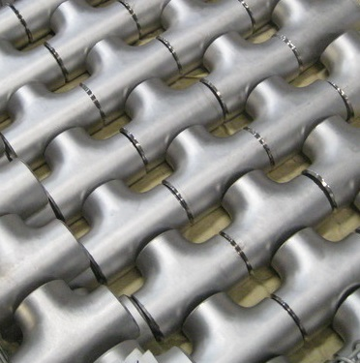!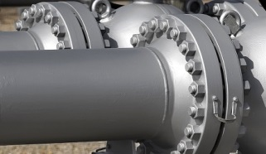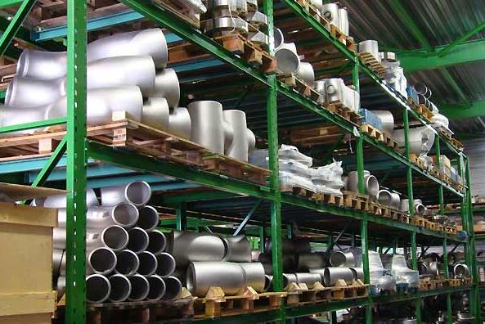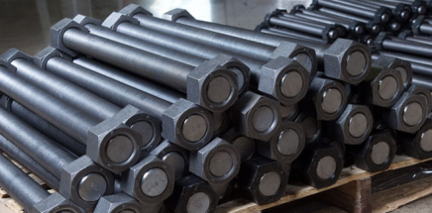

NY GLOBAL ENGINEERING
Fittings and Flanges
We have a full range of fittings and flanges in compliance to ANSI/ASME, BS & MSS standards in order to complement our pipes offerings
- Butt weld fittings
- Cast fitting and flanges
- Forged fittings and flanges
- Outlet fittings
- Pipes and swaged nipples
- Sweat fittings

PRODUCT RANGE
PRODUCT RANGE

We do not just sell things. Our pro -active approach is close communication with our customers, vendors and partners – anticipate and resolve any challenges before they become costly problems
Satisfaction
Customer
Total
!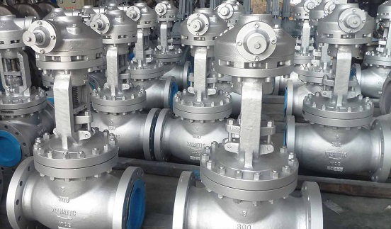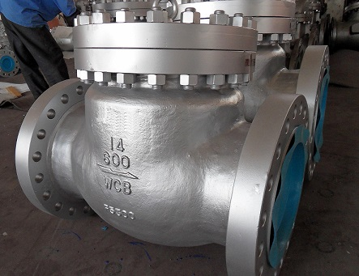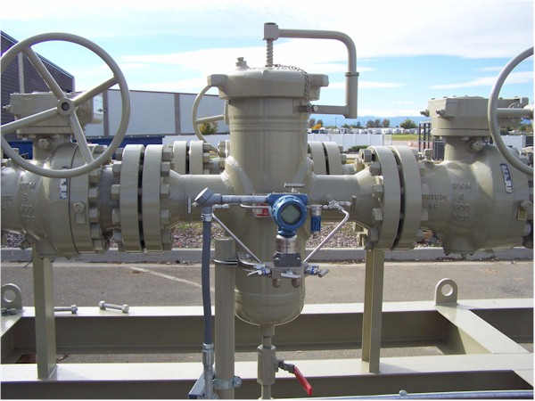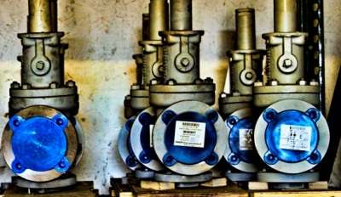

NY GLOBAL ENGINEERING
Valves
NYGE is able to source and supply almost all type of quality valves for the energy and industrial markets.

Ball Valves
- Flanged
- Threaded & SW
- Floating
- Metal Seated
- Plastic Lined
- Resilient Seated
- Trunnion
- Top Entry
- V-port
- Cryogenic

Butterfly Valves
- High performance
- Plastic Lined
- Resilient Seated
- Triple offset

We carries USA, Europe, Japan as well as Asia-Pacific brands valves that are high in quality and approved for use by global oil and gas majors in the world

Material of construction

- Carbon steel
- Low temperature carbon steel
- High yield carbon steel
- Stainless steel
- Duplex stainless steel
- Super duplex stainless steel

PressureRelief Valves
- Direct Spring Process
- Steam Safety
- Tank Protection
- Pilot Operated
- Dual Pressure Relief Device System

Strainer
- Basket
- Y-type

Check Valve
- API6A/API6D
- Lift Check
- Piston Check
- Swing Check
- Wafer Check
- Y Pattern

Multi-turn Valves
- Gate
- Globe
- Plug

- High nickel alloy
- Titanium
- Polyethylene
- Brass
- Iron
- Copper

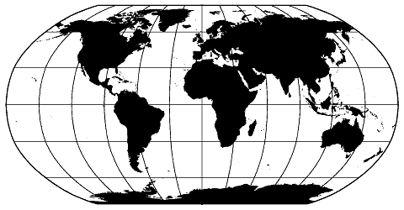
Gaskets
- Spiral Wound gaskets
- Corrugated gaskets
- Kamprofile gaskets
- CNAF gaskets
Are available to complement flanges joint management for ANSI/ASME, BS & MSS standards flanges as well as pressure vessels and heat exchangers.
We are able to supply our customer timely
- Gaskets sizes from ½” to 54” & beyond
- Pressure rating from 150# to 2500#
- Spiral wound, Kamprofile, Ring type joint (API), jacketed, reinforced metallic, corrugated metal, eyelet, PTFE envelope, EPDM metal with rubber insert gaskets
- Available in wide range of material included carbon steel, stainless steel, monel, titanium, PTFE to name a few
Packing gaskets, sheet gaskets for pumps, column internal are available upon request. We are also able to supply gaskets with customized dimension and engineering advice for flange management

Procurement Engineering Assistance

As a service of a single stop solution hub, we enhance our portfolio to provide engineering solution to all our valued customers

NY Global Engineering possesses groups of engineering expertise that have many years of experience design and plant maintenance. We are pleased to offer you the engineering solution including material sizing, development of specification and metallurgy assessment

To ease off the challenges in procuring engineered special components such as relief valves and instruments, we provide procurement assistance to our customers including
- Consolidation and evaluation of datasheets & specifications, material selection recommendation
- Gap analysis and evaluation on bids, cost effective analysis & alternatives recommendation

Fabrication Services

To reduce the time spent on turnover and increase the cost effectiveness, NY Global Engineering provides shop fabrication service. We carry services including pipe shop fabrication, tray fabrication and pressure vessel fabrication

We are committed to provide the cost effective model and convenience to our valued customers

Worldwidee
Procurement & Delivery
For any enquiry, please contact:
Sale Representative’s Name
Heng Chun Nyat/ Yang Kek Yen
Email: hengcn@nyglobal-eng.com
yangky@nyglobal-eng.com
Tel: +6012 7988696/+6 018 7805367
PRODUCT RANGE
NY GLOBAL ENGINEERING

